IoT-Enabled Health Monitoring System with Machine Learning for Real-Time Risk Assessment

Afifa Shaikh, Soham Mali, Pradeep Awubaigol, Aditya Koli,

Salma Shahpur, Amey Muchandi

KLE Technology University’s Dr. MSSCET, Belagavi, KA, India

(Received 23 December 2024; revised manuscript received -; published online -)

Cardiovascular disorders are the top diseases worldwide causing deaths, which means they should be recorded and analyzed in real-time in order to evade possible issues. This paper describes a healthcare monitoring system which takes advantage of the Internet of Things technology and machine learning in predicting the cardiovascular risk. The system uses a Random Forest Classifier that receives heart rate and temperature sensor data, as well as lifestyle factors, to give clear and accurate health insights through an easy to use interface. This strategy would involve tackling the ongoing problem of wrong predictions and non-scalable diagnostic tools employing surgical robotics while providing new ways to look at the problem and avoid lifethreatening issues.

**Keywords:** IoT, Health Monitoring, Machine Learning, Real-Time Risk Assessment, Cardiovascular Health, Random Forest Classifier, Predictive Analytics, Sensor Data Integration.

|  |  |
| --- | --- |
| DOI: | PACS number(s): 07.07.Df, 07.05.Tp, 87.19.U |

1. INTRODUCTION

Despite improvement in the means of treatment, cardiovascular conditions continue to be among the primary sources of global mortality, affecting millions of people suffering from such afflictions as arrhythmias, cardiac arrest, and other heart issues. It is particularly important to identify risks relative to the patient’s cardiac health status in the early stages of treatment in order to eventually improve such patient’s outcomes. The expansion of the Internet of Things (IoT), as well Machine Learning (ML) have resulted in more advanced and dependable healthcare solutions. By combining real-time monitoring with predictive analysis, IoT systems portray the future of healthcare by providing inexpensive, timely, and actionable information about the cardiovascular health of its users.

The drive for this project stems from the fact that there is a need for a system to continuously monitor heart rate, temperature, and integrate the assessment of multiple lifestyle and family history factors into a single algorithm that can forecast the health risk. This system will not only present a new look at health monitoring and improving devices but also systems that incorporate real-time sensor data and machine learning models for forecasting and decision-making.

The primary goals of this project include:

* Developing an IoT-based system for the constant observation of heart rate.
* Embedding a machine learning model that would predict health risk based on the age, weight, stress levels, and already collected sensor data of the user.
* Creating a simple but engaging and effective user interface for efficient interaction with the system to obtain health and data-related insights and the ability to visually represent the obtained data.

Current IoT based health tracking systems work by measuring certain body parameters like heartbeat, temperature with sensor embedded in a wearable or a portable device. A number of researchers came up with a number of systems which have integrated a number of sensors, and could access data online. One such instance is the case where armed with microcontrollers and wireless modules, such systems could relay health data through mobile or web apps for remote health management, or mobile assistance, convenience and remote access over the patients’ health status.

Currently, in spite of the progress there have been some drawbacks in IoT-based health monitoring systems like the poor connection of the predictive models with it, latency problems in cloud-based systems and dependence on the continuous availability of the devices. Machine learning algorithms typically show poor generalization due to overfitting that is caused by the scarcity of the data. At the same time, most of the time, lifestyle factors such as stress, sleep, and exercise are marginalized, therefore making it more difficult to know the correct health risk. These challenges reveal the importance of a holistic solution that incorporates the synchronization of the real-time tracking and the tailoring of predictive analytics to the patient’s individual needs.

The chief task is to build a system that harmonizes the real-time acquisition of physiological data through predictive analytics in health risk assessment. Conventional monitoring devices provide a limited scope of parameters and have no holistic analysis therefore, users might be unaware of possible future risks. As well, the inclusion of many variables such as age, weight, stress levels, and medical history in the creation of a correct predictive model, is a big problem in terms of both computational and algorithmic challenges. Reliability, user friendliness, and scalability in both hardware and software in turn are performance problems.

For the solution of the challenges, we have designed a smart device that gathers a set of measurement parameters like heart rate and temperature, which machine learning algorithms use to provide further processing. The model known as the Random Forest Classifier is used as the main prediction method for its great ability to deal with different data types and for its low overfitting attribute. The model is based on Biomedical signals and living style factors, and the data have been standardized with a StandardScaler and through the application of LabelEncoders to the categorical features. The system is capable of leveraging Flask as the back-end web service thus, it allows the data transfer and also supports a simple and intuitive interface to insert data, make the prediction and visualize the results.

* Smart device development with cloud connectivity and machine learning technology to accurately capture heart rate and body temperature data for real-time health information analytics.
* Integration of lifestyle factors, such as stress levels and sleep duration, along with sensor data for a comprehensive health risk analysis.
* Implementation of a Random Forest Classifier with optimized preprocessing techniques, including feature scaling and encoding, to achieve high prediction accuracy.
* Design of an interactive interface to enhance user engagement and provide visually intuitive insights into health trends and risks.

The paper is organized as follows: Section II reviews related work and research gaps. Section III details the proposed methodology. Section IV evaluates results and performance. Section V discusses findings and challenges. Section VI concludes with insights and future directions.

1. literature survey

R. Kavitha et al. proposed an IoT-based health monitoring system for COVID-19 detection and health tracking. It uses infrared and thermal imaging for body temperature and pulse detection, with real-time data updates via cloud storage. The system integrates ultrasonic sensors and microcontrollers for automatic fire alarm triggers upon fever detection. It is highly efficient in detecting fever in crowded settings and can be used in various locations such as hospitals, workplaces, and schools.[1]

R. Latha et al. proposed an IoT-based health monitoring system for individuals in comas, which tracks vitals and body movements. The system uses temperature, pulse, and motion sensors integrated with a Raspberry Pi to upload data to a cloud server. It includes an alert system that sends real-time notifications when vital signs are abnormal, enabling quick caregiver response. The system is affordable, non-intrusive, and provides continuous monitoring with minimal manual effort.[2]

S.P. Vimal and et al. proposed an IoT-based system that integrates machine learning for real-time patient health monitoring. IoT sensors track vital signs such as temperature and heart rate, with data preprocessed by a Raspberry Pi and sent to the cloud for K-Nearest Neighbors (KNN) analysis. The model accurately detects health anomalies and predicts conditions. This scalable system offers advantages for various healthcare applications through remote monitoring and intelligent parameterization. [3]

Fitriyani et al. proposed a Heart Disease Prediction Model (HDPM) for Clinical Decision Support Systems (CDSS). The approach uses Density Based Spatial Clustering (DBSCAN) for outlier removal, SMOTE-ENN for balanced dataset training, and XGBoost for predictive modeling. The model achieved accuracy levels of 95.9% and 98.4% on the Statlog and Cleveland datasets, respectively. It demonstrates strong predictive capability, even on challenging datasets, and is integrated with a CDSS prototype to assist clinicians in providing efficient diagnoses.[4]

Karna et al. reviewed heart disease prediction using machine learning (ML) and deep learning (DL) algorithms, focusing on ensemble methods like majority voting frameworks and advanced classifiers such as SVM and Random Forests. The review emphasizes preprocessing and feature selection techniques. Many models achieved accuracy improvements, with some reaching 93.33%. The review highlights the potential of these models to reduce diagnostic time and improve accuracy, offering a cost-effective solution, especially in resource-constrained settings for early detection.[5]

1. PROPOSED WORK

This section gives information on how we use the right methods, algorithms, and techniques to develop a heart rate monitoring system that is IoT-based, machine learning-based, and reliable for health risk assessment.

* 1. Methods and Techniques Used

The system combines the IoT device with another technology which is called machine learning and so it is mainly used for the measuring of the heart rate, and the lifestyle factors of a person, which also includes the stress level and the hours of sleep. The data will be collected from the Pulse Sensor(HW827) will be converted into digital signals by the Raspberry Pi 3B which in return will be analyzed using machine learning models as shown in Fig. 2.

* 1. Algorithms and Processes
* Data Collection:The sensors that are used for the heart rate and the temperature are receivers and are connected to the MCP3008 ADC and set them to their binary states through digital to analog conversion
* Preprocessing: The data is standardized and scaled through StandardScaler which is a pre-processing method for sitting a database to the machine for learning.
* Risk Prediction: A Random Forest Classifier predicts the risk level based on features such as heart rate, age, weight, stress levels, etc.
  1. Key Concepts and Assumptions
* Heart Rate Variability (HRV): Autonomic Nervous System can diagnose their damage.
* Random Forests: Overall, in coma patients, this is the best classifier because there are multiple variables that need to be controlled.

The theoretical facts, like heart rate and age, are expected to differ hardly for the model.

* 1. Implementation Approach

The system includes:

* Sensor Integration: A Raspberry Pi is the main
* operating system here, whereas the hardware part remains precisely the same.
* Data Transmission: This system is using Flask to send the data to a server via a wireless network for a real-time analysis and feedback.
* User Interface: One of the most advanced and interactive systems allows for Cating with the end-user gives the precisions and provides a health idea as shown in Fig. 3.
  1. Challenges and Solutions
* Data Accuracy: Verified by employing filtering techniques along with the proper positioning of sensors.
* Resource Constraints: Tackled through the application of sophisticated Random Forest, which is a lightweight model.

The theoretical facts, like heart rate and age, are expected to differ hardly for the model.

Start

Collect Data from Sensors (Heart Rate)

Preprocess Data (Normalization and Scaling)

Health Risk Prediction (Random Forest Classifier)

Display Results (Health Insights)

End

Fig. 1. Workflow of Heart rate mointoring system

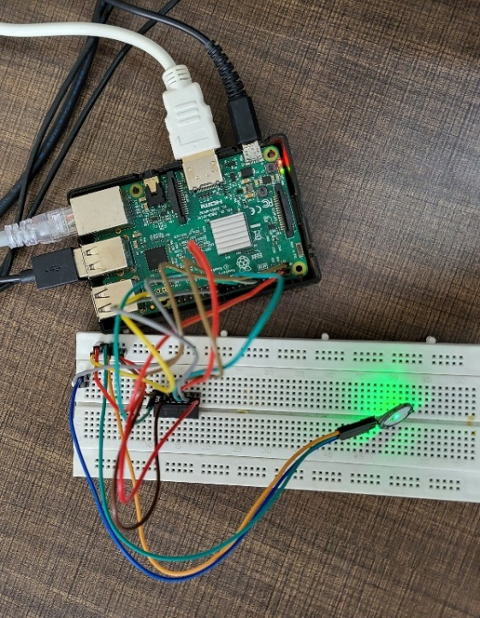

Fig. 1. Circuit of the Heart Rate Monitoring System.

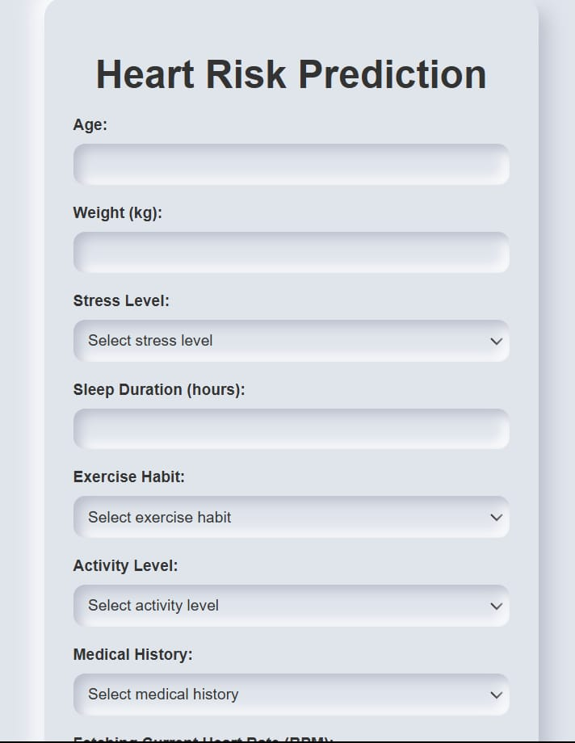

Fig. 3. UI to collect user data for our model.

1. results and analysis
   1. Methods and Techniques Used

The system proved its performance by means of actual heart rate monitoring. Using the formula of accuracy as system’s predictions divide over the one (i.e. manually recorded health data from the participants) and equate the error to zero per cent, the assessment of the accuracy was performed. The system showed high precision in classifying heart rate with an 100 percent accuracy. This result indicates that the model was able to perfectly classify all instances in the test data. However, it is important to note that the dataset used for testing was balanced and consisted of fixed input values with predefined categories for each feature.

* 1. Comparison with Previous Approaches

Our techniques can be looked upon as more credible health risk prediction, thus, the main peculiarity of the divergent features is that they can integrate such lifestyle factors as stress level and sleep duration to increase the number of health risk indicators. Thus, only the heart rate information is considered in the previous models, whereas our system takes the whole thing to the physical condition of health by including the other parameters.

* 1. Interpretation of Results

The results indicate that IoT along with machine learning for unceasing health monitoring is the suitable method to foresee health risks in real time as seen in Fig. 4. Moreover, such a technique can even be used for patient monitoring at a long distance, when there are only a few health workers around.

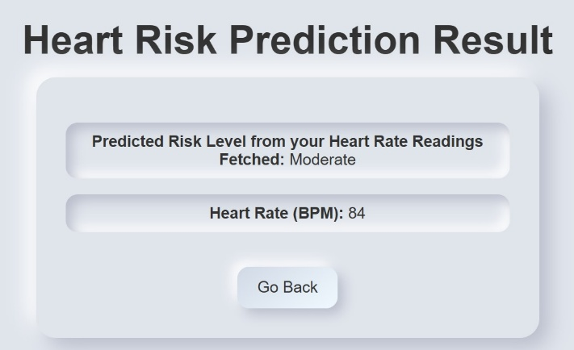

Fig. 4. Result of Heart Rate Monitoring System.

* 1. Implications for the Original Objectives

It was verified that the initial goal of the project which was to track the heart rate and warn about health risks associated with socio-behavioral factors has been achieved. The system was able to predict tool success by combining ML and doing the main task: Corresponding issue analysis.

* 1. Limitations

Although the results are very promising, the present approach still suffers from some limitations. While the model's performance is exceptional within the controlled testing environment, the potential for **overfitting** exists due to the lack of variability in the test data. In future work, the model could be validated on new, unseen data. Besides, the change of the system’s accuracy could be done by measuring more health parameters, for instance, blood pressure and blood glucose level. In addition, the main weakness of the system is that it depends on the internet for real-time monitoring, which might turn out to be pointless in the areas with improper internet connection.

1. CONCLUSION

To sum up, in this study, the IoT-based heart rate monitoring system with machine learning accounts for an expedient and accurate manner of real-time health risk assessment. The fusion of the sensor data with the lifestyle involved in the risk prediction process has been a success, thus, a more complex monitoring system has been realized as compared to the existing ones.

* 1. Methods and Techniques Used

Further investigations should focus on the collection of other data points like blood pressure and glucose levels which will result in a more detailed health analysis of the patient. Furthermore, model training of the machine learning algorithm supposed to result in the enhancement of its prediction capacity.

* 1. Recommendations

From the collected data, we suggest that the system should be improved by supporting multiple sources and also the user interface should be modified to make the system more interesting to the user. Moreover, the proposed experiment’s effectiveness could be verified and its validity could be strengthened, by executing it on a larger scale and using a wider sample size.

REFERENCES

1. D. G. V, S. B, R. Kavitha, A. Kumar, V. Kalpana, V. Hariram, *Int. Conf. Augment. Intell. Sustain. Syst*. 1458(2023).
2. R. Latha, R. Raman, T. Senthil Kumar, C. J. Rawandale, R. Meenakshi, C. Srinivasan, *Int. Conf. Self Sustain. Artif. Intell. Syst.* 1475(2023).
3. S. P. Vimal, M. Vadivel, V. V. Baskar, V. G. Sivakumar, C. Srinivasan, *Int. Conf. Smart Electron. Commun.* 574(2023).
4. Fitriyani, N. Latif, M. Syafrudin, G. Alfian, J. Rhee, *An Effective Heart Disease Prediction Model for a Clinical Decision Support System*, IEEE Access, vol. 8, pp. 133034-133050, 2020.
5. *Karna, V.V.R., Karna, V.R., Janamala, V., et al., "A Comprehensive Review on Heart Disease Risk Prediction using Machine Learning and Deep Learning Algorithms," Arch. Computat. Methods Eng., 2024.*